Sir BEHRAJ’s Assignment

**Boolean Algebra and Logic Simplification**

**Q1.** Obtain a reduced expression and realize the function using NAND gate only. F(A, B,C,D) =

Σm(3,4,5,,7,9,13,14,15) + Σd(0,2,8).

**Q2.** Simplify F(A,B,C,D)= Π(0,2,5,8,10)+d(7,15). Write its standard Sum of product and implement the simplified circuit using NOR gate only.

**Combinational Logic Analysis**

**Q3**. Design a logic circuit that allows a signal to pass to the output only when one, but not both, of the control inputs are HIGH; otherwise, the output will stay HIGH or it should be **(low)**

**Q4.** Design a logic circuit with input signal A, control input B, and outputs X and Y to operate as follows:

1. When B = 1, output X will follow input A, and output Y will be 0.

2. When B = 0, output X will be 0, and output Y will follow input A.

**Functions of Combinational Logic**

**Q5.** Use the 4-bit parallel adder truth table to ﬁnd the sum and output carry for the addition of the following two 4-bit numbers if the input carry (Cn-1) is 0: A4A3A2A1 = 1100 and B4B3B2B1 = 1100.

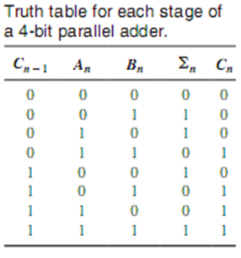

**Q6.** Design a 2-to-1 lone multiplexer. Draw the truth table and write down the logic expression as well.

**ANSWER:**

The output is I 0 when Select value is S = 0 and the output is I 1 when Select value is S = 1.

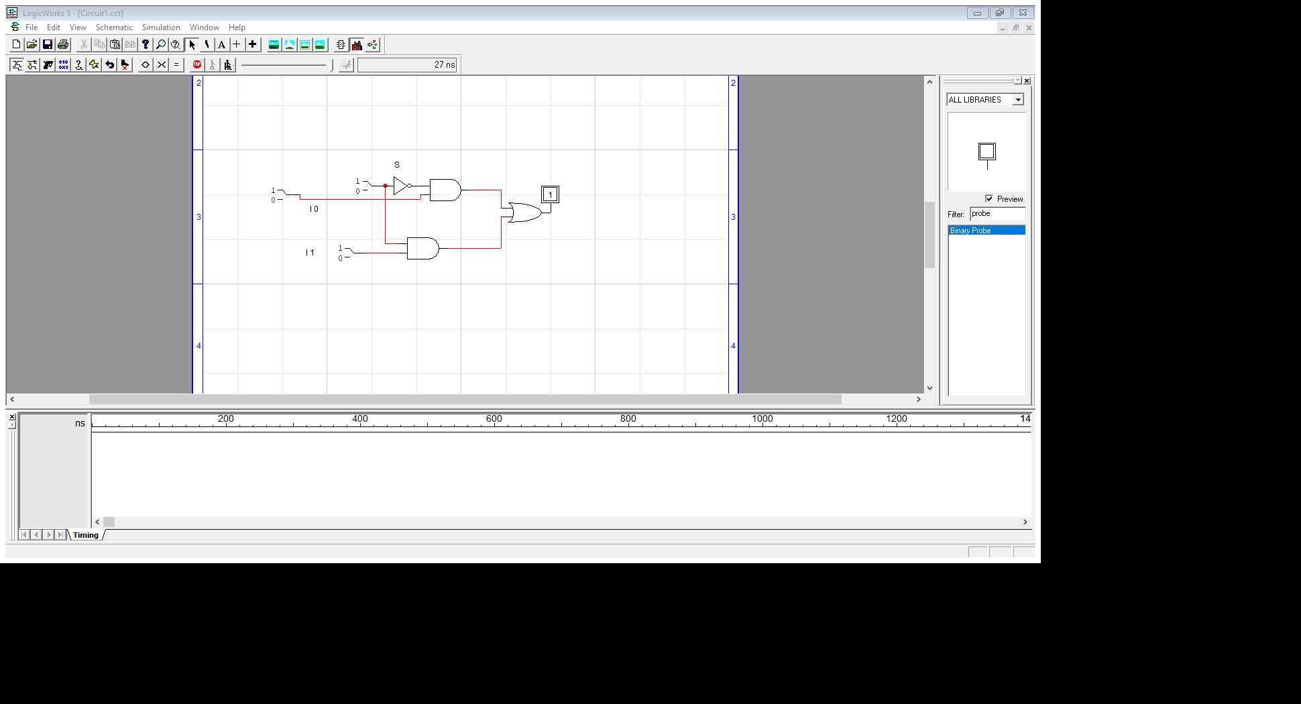Expression, Y = S` I0 + S I1

|  |  |  |  |
| --- | --- | --- | --- |
| S | I 1 | I 0 | Y |
| 0 | 0 | 0 | I0 : 0 |
| 0 | 0 | 1 | I0 : 1 |
| 0 | 1 | 0 | I0 : 0 |
| 0 | 1 | 1 | I0 : 1 |
| 1 | 0 | 0 | I1 : 0 |
| 1 | 0 | 1 | I1 : 0 |
| 1 | 1 | 0 | I1 : 1 |
| 1 | 1 | 1 | I1 : 1 |